**Stamford After-School Providers!**

Please attend our first quarterly meeting.

**Wednesday, November 16th   
 11am – 1pm**

**LOCATION:** Domus, 83 Lockwood Avenue: Park on the street or in the back parking lot off Frank Street; enter through front of building (buzzer entry).

***AGENDA:***

QPR Training 11-12:30 (see below)

Networking/Resource Sharing 12:30-1pm

*Lunch will be provided.*

**Question, Persuade, Refer**

QPR is an evidence-based suicide prevention program that teaches three steps anyone can take to save a life.

**Become a Gatekeeper:**

Recognize Signs - Offer Help - Connect to Resources

Click [HERE](https://qprinstitute.com/become-an-instructor) to read the complete course description, or point your camera here

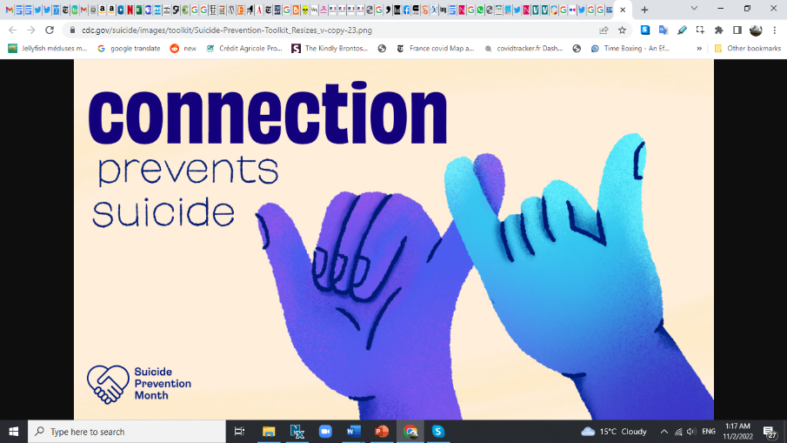

We need a headcount, so please RSVP by November 11th to [jdegennaro@domuskids.org](mailto:mailtojdegennaro@domuskids.org).

*This is an initiative of the Stamford Youth   
Mental Health Alliance.*

Any questions? Please contact Julie at [jdegennaro@domuskids.org](mailto:jdegennaro@domuskids.org).